Quiz April 26, 2018 Name___________________________________________________
- What is the exact name of the most important file on a web server?

- To add a field to the description of a database table or to increase the size of that field, which of the following is used?
DML DDL

- To select specific records from a database table, which of the following is used?

DML DDL

- What is the file extension of an MS Access database?

- Identify 2 likely business rules associated with a field called firstName.

- What is the term that indicates the MS Access database management system will select the next primary key?

- A _______________________ can be used at the GUI layer / User Interface layer to ensure that only valid values enter a database table/field.

8.
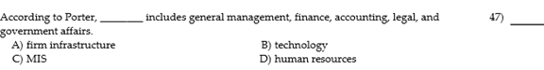

9.
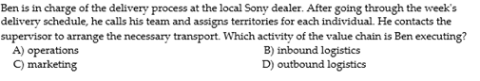

10. Where does one designate a foreign key in MS Access?

